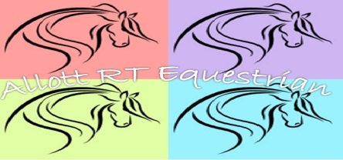
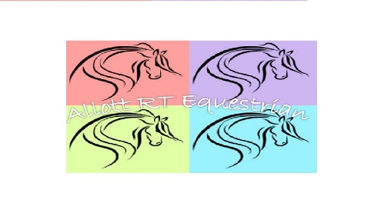
ALLOTT RT EQUESTRIAN
SPORTS, REMIDIAL AND MANIPILATION MASSAGE PRACTITIONER & THERAPY AND REHABILITATION THERAPIST.

CONSENT FORM
Karen Allott BSc (Hons) EMAP (Dist)
allottrtequestrian@gmail.com

HORSE OWNER INFORMATION

Name | Address  Telephone Number:
I/we declare that I/we are the legal owners of the horse named below and that the information shown in this form is correct and we fully accept the terms and conditions printed on page 2.

Signature(s):

Date:

HORSE & VETERINARIAN INFORMATION

NAME | BREED
COLOUR | HEIGHT AND APPROX. WEIGHT
SEX | AGE
PRE-EXISTING CONDITIONS
Veterinarian Use: Verbal Consent: Yes/No

Veterinarians Signature:

ALLOTT RT EQUESTRIAN - TERMS AND CONDITIONS

1. In accordance with the Veterinary act 1966 the owner has legally signed the above document to state that they have informed their current veterinarian professional and sort guidance, written and or verbal that the horse stated in the above document is eligible to be treated by Allott RT Equestrian in accordance with the act.

2. A copy of the treatment sheet will be provided at the time of treatment. Records of the treatment will be held on file in accordance with the Data Protection Act 1998 and any request of further copies of the treatment record post treatment will be charged in accordance with administration fees.

3. Any employee of Allott RT Equestrian will take care and attention at all times during the course of treatment.

4. The owner must notify Allott RT Equestrian of any conditions the horse may be suffering from that could affect the massage and horse’s with infectious or contagious conditions will not be treated. The owner must notify Allott RT Equestrian if the horse’s injury or condition worsens during any massage treatments.

5. Allott RT Equestrian reserves the right to refuse to treat any horse.

6. Allott RT Equestrian reserves the right to use film footage/photographic during treatment sessions for reference purposes. Full written consent from the horse owner/handler must be obtained should Allott RT Equestrian wish to use any images or footage for any other purpose (including but not limited to websites, case studies, advertising or promotion).

7. Owners are requested to be present during the treatment and abide by the health and safety guidelines of Allott RT Equestrian which will be communicated by the practitioner.

8. Treatments undertaken on the horse and any findings by the practitioner will be treated confidentially and only discussed between Allott RT Equestrian, Owner/handler and Veterinarian as necessary.

9. Allott RT Equestrian does not take any responsibility whatsoever, wheresoever or whosoever for any accident/injury or losses sustained during a massage treatment. Horse massage is done so at the owner’s own risk.

10. Allott RT Equestrian does insure that adequate public liability and malpractice insurance cover is in place before commencing treatment.

11. Any and all advice provided by Allott RT Equestrian will be based solely on the findings from the treatments undertaken. It is the duty of the owner/handler to decide if they wish to follow the advice/treatment regimens suggested by Allott RT Equestrian

